You need to develop an application for cab service providers by implementing the classes based on the class diagram and description given below.

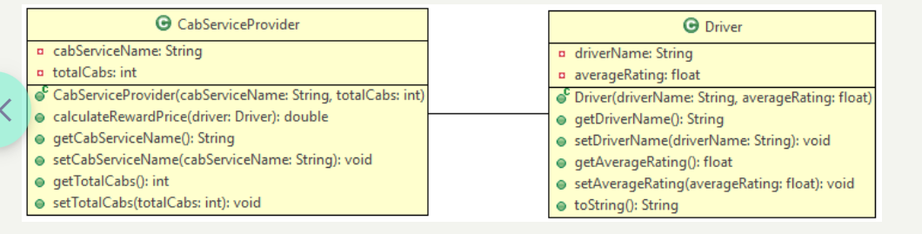

Note: Driver class is provided to you.

**Method Description**

**CabServiceProvider**

**CabServiceProvider(String cabServiceName, int totalCabs)**

* Initialize all the instance variables appropriately with the values passed to the constructor.

**calculateRewardPrice(Driver driver)**

* Calculate and return the bonus of the driver based on the below table. If averageRating of the driver is less than 4, return the bonus as 0.

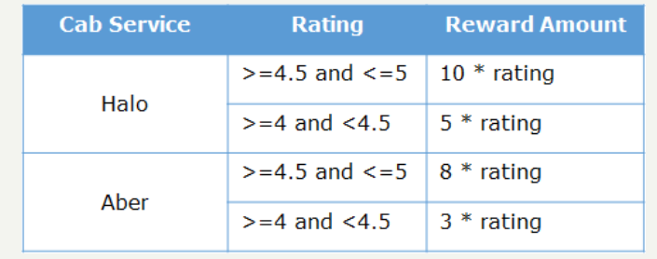

* In case of any invalid value, return the bonus as 0.

Note: Round off the bonus to 2 decimal digits.

Implement the appropriate getter and setter methods.

Perform case-sensitive comparison wherever applicable.

Test the functionalities using the provided Tester class.

**Sample Input and Output**

**Input**

For CabServiceProvider object cabServiceProvider1 with cabServiceName = Halo and totalCabs = 50

Driver object - driver1

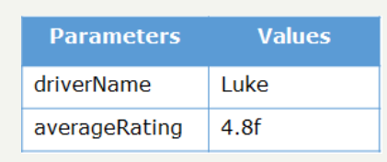

Driver object - driver2

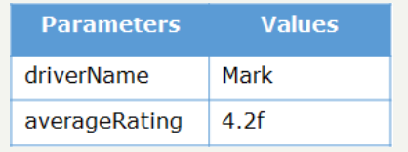

Driver object - driver3

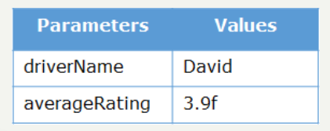

**Output**

